********

**Abstract**

In the 21st century, a lot of industries such as Banking, Finance, Manufacturing and Agriculture have been influenced by the recent rise in technological advancement. This phenomenon has indirectly shifted the focus of these industries from preserving their traditional ways of doing business to introducing technology into their business, which resulted in an increase of efficiency and effectiveness of their day-to-day operations. The healthcare industry is also moving into this direction by instilling more ubiquitous electronics such as high-resolution 3D imaging system and artificial intelligence aided the healthcare system that can assist physicians in making better clinical decisions. The potentials of technology are virtually endless with the massive amount of data and data analytic methods that are being developed in this day and age [1].

However, there is one niche area that is relevant to all of us yet hasn’t been keeping up to the pace of technology which is the emergency service that is provided by many countries. Nowadays, emergency service is still contacted via the dial of single emergency telephone number that is easily remembered as it is typically a three-digit number. Once an emergency call is made, it is usually answered by a telephone operator that will ask for more information about the emergency and connect to the appropriate emergency services for help. This 999 call was originated in London in 1936 and has not undergone any significant changes since [2]. In this paper, a new emergency calling mobile application is proposed as an extension to the current emergency service system by utilizing the technology available in a smartphone such as Geographical Positioning System (GPS), voice recognition service that enables real-time speech to text conversion and natural-language-processing (NLP) service that can interpret the extracted texts for more information.

**Keywords** Smartphones · Emergency service · Emergency · Mobile Application · Voice Recognition · Natural-Language-Processing · Healthcare · Emergency Delay

**Acknowledgements**

I would like to first recognize the person that has helped me throughout the idea-generating phase, planning, design and implementation of the project which is none other than my final year project supervisor, Mr. Chew Sze Ker, who dedicated his valuable time to meet up with me every week to give valuable feedback and advice. His advice eventually helped in the development of the final year project and writing of the report which no amount of words can describe how grateful I am for his patience.

Besides that, I would like to thank my family and friends that understood my circumstances and supported me throughout the year without any hesitation. Although there are many obstacles and setbacks that had been encountered, all of them were solved with their kind generosity. Without them, this final year project wouldn’t come to fruition.

**Definitions, Acronyms, and Abbreviations**

*Table 1 Definitions, Acronyms, and Abbreviations*

|  |  |
| --- | --- |
| **Term** | **Definition** |
| GPS | Global Positioning System |
| EMS | Emergency Medical Service |
| NLP | Natural Language Processing |
| API | Application Programming Interface |
| UI | User Interface |
| JSON | JavaScript Object Notation |

## 

Table of Contents

1.1 Problem Statement 1

1.2 Motivation 1

1.3 Background 2

1.4 Intended Audience 4

1.5 Aims and Objectives 4

1.6 Project Scope Description and Limitation 5

1.7 Timeline (Gantt chart) 6

1.8 Milestone 7

2.0 Literature Review 8

2.1 similar applications that have been developed 18

3.0 Scrum Framework 19

3.1 Product Backlog 19

3.2 Release Backlog 19

3.3 Sprints 20

3.4 Burndown Chart 21

4.0 Software Requirement Specification 22

4.1 Functional requirements 22

4.2 Non-functional requirements 24

4.3 UML Figures 25

4.3.1 Use Case Diagram 25

4.3.2 Activity Diagram 26

4.4 Prototypes 27

4.4.1 Low-fidelity 27

4.4.1 Mid-fidelity 28

4.4.2 High-fidelity 29

5.0 Implementation of project’s application 30

5.1 Tools used in the development process 30

5.1.1 Android Platform 30

5.1.2 Adobe Illustrator 32

5.1.3 Google Firebase 33

5.1.4 Google Android Speech-to-Text API 33

5.1.5 Google Maps / Places API 34

5.1.6 Microsoft Language Understanding API (LUIS) 35

5.2 Design and architecture of the application 36

5.2.1 Frontend 36

5.2.2 Backend 38

6.0 Results & Discussions 39

6.1 Voice recognition test 39

6.2 NLP test 41

6.3 Comparison of intents score 42

7.0 Contribution and reflections 47

8.0 Bibliography 48

## 1.0 Introduction

### 1.1 Problem Statement

During an emergency like a fire break or an accident, citizens in most countries will call an emergency number to contact the required departments to save the situations. In explaining the concept of this project, we will be focusing on accidents that are related to health or a car accident as the underlying concept is applicable to the other two emergency services which are a police station and fire station. However, the mobile application developed for this project can be used to call all three emergency services (police station, fire station, hospital). Having a universal emergency number in a country is useful to the people to call for help. Nevertheless, once the person had made the call, several questions like the location of the person and problems faced are asked by a human operator before the call can be relayed to the appropriate department.

In a time of emergency, it is easy to introduce human errors (especially calls made by elderly people that often causes these issues) that might delay the process of having the problem solved. Therefore, by creating an application that automates some crucial tasks like real-time location fetching and user’s information extraction, we can save minutes and seconds that could determine the life and death of the victims involved in an accident.

### 1.2 Motivation

There are many motivations for taking up this project. For example, the number of deaths or serious injuries that can be avoided due to the delay of ambulances is still present in Malaysia. Although the traffic jam issue or inconsiderate drivers on the road can be blamed for the delay, every single ambulance calling and ambulance dispatching process should be taken into account to make it more effective and efficient.

Indirectly, the response time of an ambulance could affect the treatment of the patient as the patient that is sent to the hospital in a shorter time has a higher chance of survival by being treated in time. The current ambulance response time set by the former Deputy Health Minister Datuk Seri Dr Hilmi Yahaya is 15 minutes, yet in some cases, the ambulance might take up to 35 minutes to arrive at the destination [3]. Imagine a world where ambulances services are always available within 5km and anyone can call for an ambulance instantly at any time, anywhere. This is the world that we strive to build, and this project is the first step towards achieving that goal.

Several applications that have the same idea had been proposed and built in the past (e.g. Doctor2U application) but the execution for these applications are different as voice recognition and natural-language-processing technology will also be implemented in this application to process what the caller is saying to better identify the accident taking place, making it less error-prone.

However, this application is not meant to replace a human operator but enhancing the procedures of calling for emergency service. Therefore, the human operator involved should see this application as an extension instead of a replacement and provide services to the user when the application is not capable of solving the problems the user had in mind.

### 1.3 Background

Life is precious and valuable, yet most humans live their lives without ever being grateful for the opportunity to breathe, see, hear and love in a meaningful way. The realization only comes when he or she is having an emergency or moment that will determine a person’s life and death, only then people will start appreciating what they had in life all these times. However, sometimes a short delay of an ambulance in times of emergency will take away all hopes and dreams of people that want to be better, people that can become future leaders or people that play a major role in society.

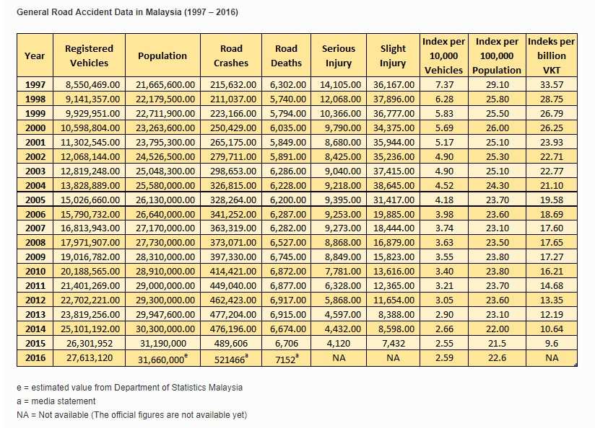

*Figure 1.3 Number of road accidents in Malaysia from 1997 to 2016* [4]

According to Figure 1.3, the number of death related accidents in Malaysia has increased in recent years. At the same time, it has made Malaysia the 3rd highest accidents’ death rates globally, higher than both China and India. The Government has put in a lot of effort to improve the prehospital emergency medical service to compensate for the fatality of each car accident. Depending on the situation, human can lose about 10% to 15% of blood before there is a serious medical concern [5]. Thus, ambulance services must be enhanced to the point of precision where victims of the accident can be sent to the hospital and be treated before serious blood loss that leads to death or coma due to lack of blood flow in the brain. Despite the effort, countless stories of victims died due to the delay of ambulances have been unexpectedly high in recent years although we have made advancement in the realm of technology [6]. There are many reasons that contribute to this issue, one of them is the process of calling for emergency help.

For example, after dialling the number 999, the caller will be assisted by a professional emergency operator (PEO) that will ask various questions like the emergency involved and the severity of the incident. Other than that, the personal information of the caller like his current location, age and name will also be asked to validate the call. Then, the operator will redirect the caller to the emergency services in need and further assist the caller. The layers of people involved in the call might also introduce undesirable human errors that will again delay the arrival of the ambulance. Therefore, it is not a want, but a necessity to improve the way Malaysians call for an emergency with the help of technology and data.

### 1.4 Intended Audience

The intended audience for this application would be the citizens of Malaysia since the services being offered now are from Malaysia based companies. This will be the case until the application is matured enough to be expanded to the globe. This will be possible by doing more researches on how other countries operate their emergency service infrastructures and make modifications to the application to better suit the country’s services individually.

### 1.5 Aims and Objectives

The aim of this project is to create a mobile application that gives the user the ability to call for emergency help without going through the usual procedures and ensure the appropriate help is arrived at the required location using the shortest time possible. The objectives of this project are:

* Using Natural Language Processing (NLP) technology to process what the caller is saying and extract important keywords (e.g. car accident, firebreak, burglars etc.) to determine the type of emergency help needed for the situation, thus reducing human error and increasing the precision of the overall emergency system
* Using Global Positioning System (GPS) that is available in the smartphone to determine the location of the caller precisely. By having the location information, the emergency service headquarters will determine the nearest appropriate emergency centre to contact. The location information is then conveyed to the centres that will dispatch the help using map services like Google Map
* Markers of the nearest emergency centres will be shown to the user for reference
* Give the user the option to call for a professional emergency officer directly if there are any doubts or questions

### 1.6 Project Scope Description and Limitation

In this project, an Android mobile application will be created using a software called Android studio that is provided by Google. This application will have the function to call for emergency help with just a tap of a button. Besides that, the application uses the GPS technology that is available in smartphones to determine the precise location of the user that called for an ambulance. Other than that, it will also include a speech recognition technology that will analyze and extract keywords from the voice note given by the caller during the emergency calling process. For example, short voice notes like “There are two people involved in a car accident”, keywords such as ‘accident’ will be extracted and interpreted, which conclude that a car accident is present and an ambulance with the right equipment for a car accident should be dispatched. There will be instances where the user is more comfortable talking to a human operator during an emergency event. Therefore, there will be a button inside the application that enables the user to contact an emergency centre directly via the traditional phone calling method through dialing 999.

The design of the application will also be minimalistic yet functional, ensuring the learning curve to use the application is gradual. However, there will also be some limitations to the mobile application. As this application is an Android application, it will only work on an Android phone and not on an iOS device. Furthermore, WIFI or mobile data is required to use the application as it needs to send and receive data from the backend server to communicate with the emergency response centres. Although GPS in the application can work without the need of internet, it is safer to combine both internet and GPS data to pinpoint the location of the caller. At the same time, the voice recognition feature that is present in the application will only work with the English language now due to the limitation of the application program interface (API) being in use.

### 1.7 Timeline (Gantt chart)

(printed Gantt chart stick on a physical copy of the report)

### 1.8 Milestone

|  |  |  |
| --- | --- | --- |
| **No.** | **Individual Milestone** | **Date completed** |
|  | Function to call for emergency help is reliable | 1st December 2018 |
|  | The live location of the user can be extracted and sent to the database | 25th December 2018 |
|  | Keywords can be extracted and interpreted successfully from the processed voice note | 15th January 2019 |
|  | Voice note from the user can be processed, analyzed by the using NLP service | 25th January 2019 |
|  | The required emergency help is dispatched based on the request received | 12th February 2019 |
|  | Markers of nearby emergency centres are shown on the Map for references | 1st March 2019 |

## 2.0 Literature Review

The emergency number 999 is the world’s oldest emergency call telephone service and it is used in the United Kingdom, Malaysia, Macau and many more countries. First introduced in London in the year 1937, the emergency system was invented after five fatalities were found in a fire at a London doctor's surgery when the fire brigade was unable to be contacted due to the line being held back in a queue by the Welbeck telephone exchange [7]. By having a standard easy-to-remember nationwide number to alert the emergency services, the whole procedure is more streamlined and efficient for both ends of the parties. In this project, Malaysian Emergency Response Service (MERS) will be discussed in detail including the pros and cons of the system and how the proposed mobile application can be built on top of the system, utilizing cutting edge technologies like voice recognition and natural-language processing.

The Malaysian Emergency Response Service (MERS), which is an integrated system to automate emergency call taking and dispatching, was founded in 2008 by the Government with the initiative to consolidate all emergency numbers in Malaysia into a single emergency number (999) for public conveniences. MERS 999 concept was inspired by 9-1-1 National Emergency Number Association (NENA) and the European Emergency Number Association (EENA) which is responsible for emergency calls in North America, Canada and Europe countries. MERS 999 has access to five emergency departments in Malaysia which are the Royal Malaysian Police, Fire and Rescue Department, Health Ministry, Civil Defense Department and Malaysian Maritime Enforcement [8].

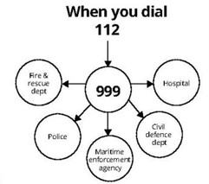

*Figure 2.1 Departments that can be accessed by dialling 112 or 999*

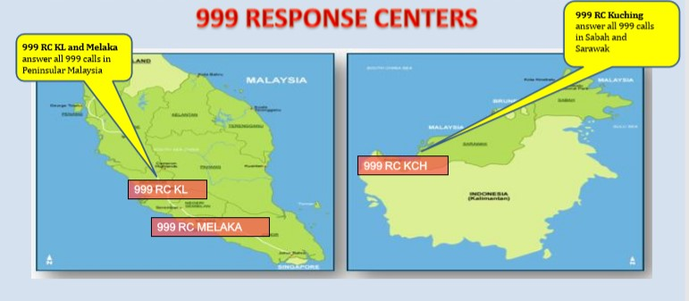

*Figure 2.2 Response centres location in Malaysia*

As seen in Figure 2.2, there are a total of 3 response centres in Malaysia. When an emergency call is made by the caller, the call will be relayed to the nearest response centre and answered by a professional emergency operator (POE) within 20 seconds. The operator will then ask the caller for some basic information such as location, address and contact number to verify the genuineness of the call. Once the call is verified, the call will be relayed to the appropriate department to aid the caller [9]. The Figure below shows the flowchart of the call taking the process at a 999 response centre:

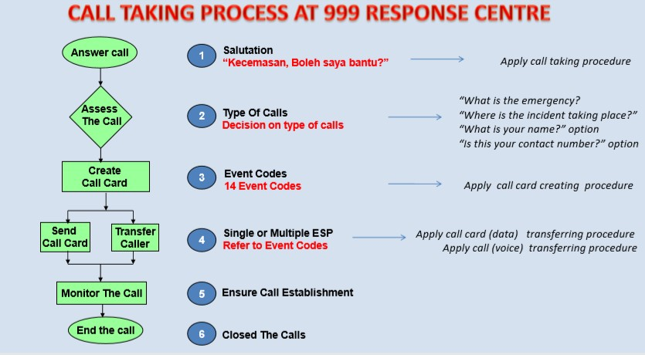

*Figure 2.3 Flowchart of call taking process for MERS*

In the meantime, the project details will be explained by focusing solely on one of the emergency departments in MERS which is the ambulance emergency service department. The Emergency Medical Service (EMS), which is a system involving multiple people and agencies that are responsible for providing emergency medical care [10], is composed mainly of three tools:

1. Computer Telephony Interface (CTI)

* Cutting-edge computer telephone technology delivers the latest tech in call processing to filter spam calls
* CTI integrates with the emergency lines allowing to delimit safety parameter from an address and instantaneously produce an exhausting list of addresses

1. Computer Aided Dispatching (CAD) system

* A powerful real-time command & control process, that tracks information relating to all calls and field unit activities
* Captures incident related information, resource availability, resource status & resource recommendation

1. Geographical Information System (GIS).

* Integrated to the CAD System as a tool in visualizing the overall situation
* Can visualize the location of calls, incident, vehicles & resources tracking through GPS & Automated Vehicle Location System (AVLS)

Given the sophistication of the system, the system is still not a perfect solution as there are a few apparent challenges that will cause needless complication:

* Difficulties to determine the precise incident location (5km or more radius)
* Data accuracy from the cellular provider (Longitude and Latitude) and profile of the caller might be different

* The geocoding process must be improved continuously due to the dynamic movement of the telephone subscribers and new development of residential areas
* Geographical Map in the system need to be updated due to the changing landscape from constant new developments in the area

* Sharing of common information among all different emergency departments must be consistent

By examining all challenges faced by the system, it is safe to conclude that the process of locating the caller is quite complicated and the maintenance of the system over time is time-consuming and cost-intensive. Hence, the proposed mobile application is designed to decrease the complexity of the system and ease the software maintenance development process for all emergency centres.

To design and create a reliable mobile application, the ins and outs of an emergency service system must be studied and researched thoroughly. The current flow of calling for an ambulance works in the following way:

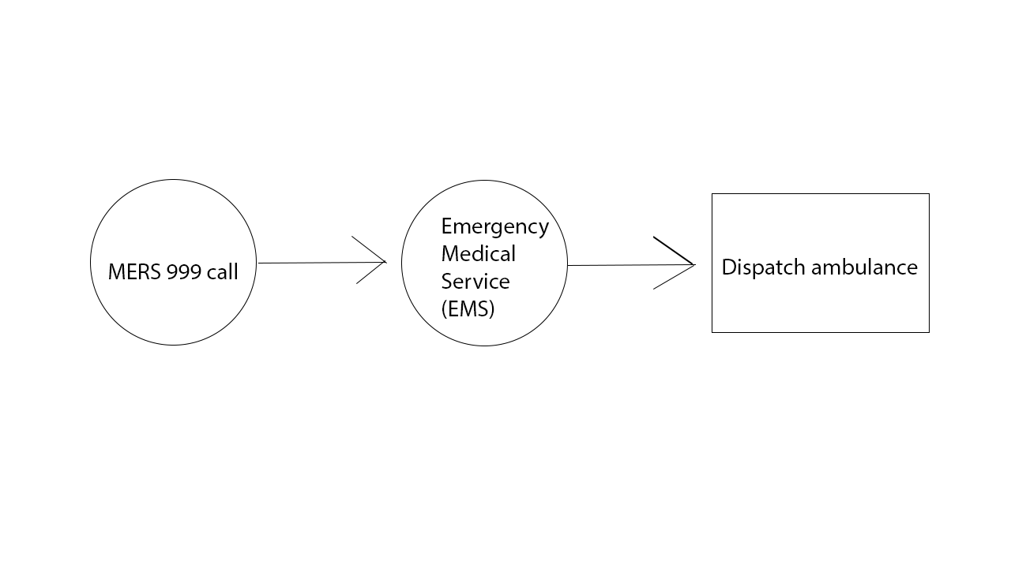

*Figure 2.4 Flowchart of call taking process for a medical emergency help*

Although a phone call is a familiar way of calling for emergency help, the services could be further extended by giving the public direct access to the EMS through the use of mobile application. This change in paradigm can be visualized in the following way:

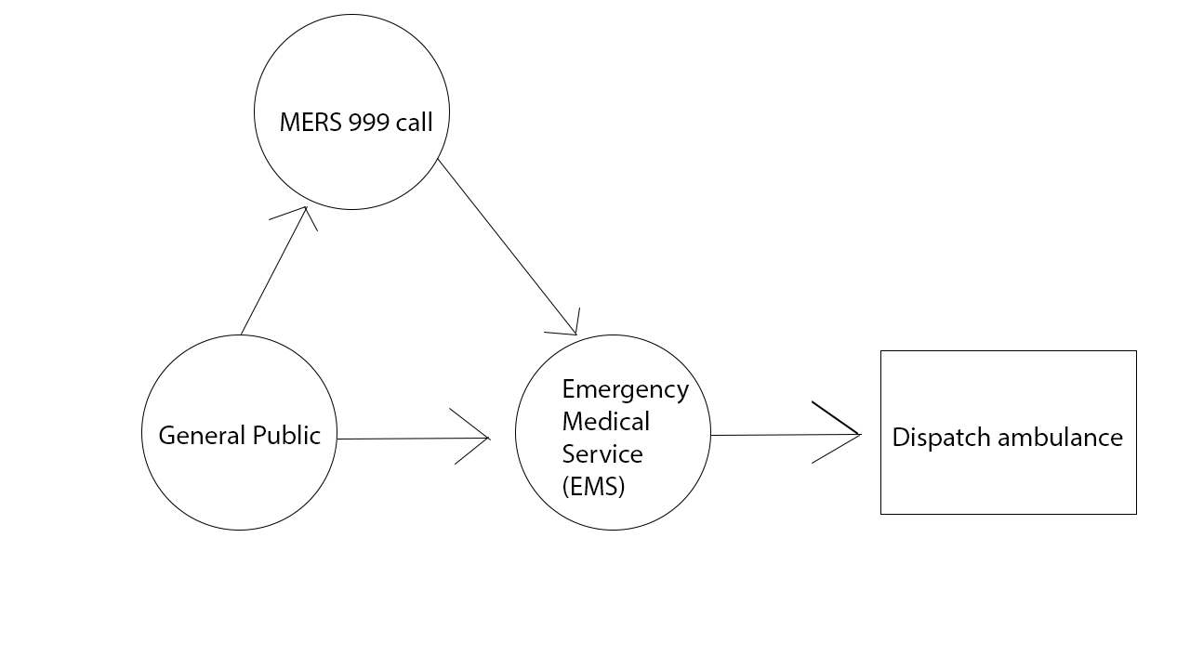

*Figure 2.4 Proposed Flowchart of call taking process for a medical emergency help*

With the newly designed flow, the public can directly contact the EMS for an emergency help instead of going through MERS 999, which will now act as an extension to the service by providing assistance to the caller if it is needed. The flowchart illustrated above is the basic procedure of MERS 999 and in the following section, the technicality of the proposed system will be described systematically.

According to Pieterse & Olivier, the usage of smartphones has been on the rise, making Android operating system one of the most prominent mobile operating system in the world [11]. Since the purpose of an EMS is to provide immediate medical help in an emergency, having a mobile application developed using Google’s Android platform for this purpose is the next logical step to push this niche sector forward. One of the core functionalities of this mobile application will be depended on the GPS that is present in every smartphone. Generally, GPS can be classified into three categories:

1. Survey-grade

* Capable of determining locations to within 1 cm of true position [12]
* Infrastructure cost can exceed up to $25,000
* Requires satellite signal reception that is often unstable in a remote area or forested landscape

1. Mapping-grade

* Capable of returning accuracies within 2 – 5m of the true position
* Infrastructure cost ranging from $2000 to $12,000
* Results are largely depended on the quality of the equipment and the skill of the operator

1. Consumer-grade

* GPS receivers cost less than $100
* Capable of returning accuracies within 10 – 20m of the true position

The mobile application that is being developed in this project can tap into the consumer-grade GPS that is available in very modern smartphones. Thus, it is crucial to identify the difference in coordinate data that have been collected by these GPS. By comparing consumer-grade GPS and other GPS receivers, it is the quality control of satellite reception that separates them where there are a different minimum reception quality standard and the number of points needed for coordination determination [13]. Nevertheless, the default GPS receiver that present in today’s smartphones is commensurable for extracting precise enough coordinate data from the user.

GPS works by having multiple GPS satellites broadcasting radio signals to the GPS device which then uses the information received (locations, status, precise time) for the geometrical calculation to get the location on Earth in three dimensions [14]. This will ensure that the location data is in real-time and streamline the process for the emergency help i.e. ambulance to travel to the intended location in time. Moreover, the complexity of the Geographical Information System (GIS) present in EMS can be replaced by GPS real-time location, ensuring always up-to-date data with the assistance of Google Map application programming interface.

After solving the location data extraction complexity of EMS, serious thoughts have to be given to the way a user wants to use his or her application. There are many ways that a mobile application can be designed to send an emergency request, for example: designing the mobile application like a text messaging application and requiring the emergency situation to be sent in text form. However, from a mobile Human Computer Interaction (HCI) perspective, this form of design might cause situational impairments such as limited visual attention while driving or limited hand availability during certain activities, especially during emergency situations [15]. Instead of needing the user to type the emergency situation out, the main feature of the mobile application (i.e. call for emergency help) will be created with voice recognition technology. The benefits voice recognition bring to the mobile application are apparent, for example: Imagine a man is having a heart attack, by just clicking on a simple button in the mobile application, he still has a chance to utter words about his wellbeing. Without worrying about the words that he needs to type out with a traditional mobile application, his voice note will be transcribed and sent to EMS.

In a time of emergency, human errors are easily introduced unintentionally too. Therefore, the implementation of voice recognition technology in the mobile application is used to reduce human errors. When the user tapped on the button to call for emergency help, a pop-up window is shown to the user with the capability of sending a voice note. Voice note is preferred over text messaging as speech conveys more information and proper identification. The voice note is analyzed by the voice recognition technology and specific keywords extracted will be sent to the EMS to choose the appropriate ambulance to be dispatched. Voice recognition technology: speech-to-text work by incorporating a different type of speaker model, type of vocal and speech utterance [16]. Below is an overview of how a general voice recognition system works:

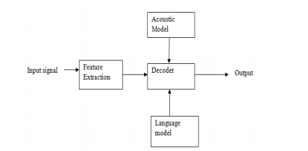

*Figure 2.5: Overview of a general Voice Recognition System: Speech-to-text.*

**The explanation for each term**

* **Input signal**

Voice input by the user

* **Feature Extraction**

It should retain useful information of the signal, deduct redundant and unwanted information, show less variation from one speaking environment to another, occur normally and naturally in speech

* **Acoustic model**

it contains statistical representations of each distinct sounds that make up a word

* **Decoder**

it will decode the input signal after feature extraction and will show the desired output

* **Language model**

it assigns a probability to a sequence of words by means of a probability distribution

* **Output**

interpreted text is given by the computer.

As seen in Figure 2.5, the input signal is quite important as the speech data (what was said by the user) will often contain background noise, which can interfere with the recognition process. It is the feature extraction part of the system that will be responsible to process the incoming input signal and convert it into a format best suited for further analysis. The words and phrases as well as the knowledge of the environment in the form of an acoustic model will be taken into consideration. Once the utterance was processed, the result is either “accepted” or “rejected” where accepted utterance is successfully transcribed into text. In the case where the input signal is said using weird accent or wrong pronunciations, the closest match of words will be returned as output. All output returned as the transcribed text will be in text string format [17].

Once the output of the voice note is extracted, the output will be processed and interpreted by natural-language-processing technology to determine the type of emergency help that is being requested. Natural-language-processing works by involving the use of machine learning algorithms and “narrow” artificial intelligence (AI) to understand the meaning of a given text in any medium such as medical documents, financial documents and legal documents. Since machine learning needs to learn from a learning framework, the quality and quantity of training data are important to create a good machine learning model. Unlike algorithm programming that is static, a machine learning model can generalize and deal with novel cases based on prior “learning” when evaluating a case [18]. The whole process involves the use of statistical techniques for identifying parts of speech, entities, sentiment and other expects of text.

In this project, the mobile application has a voice note feature that can be categorized as a conversational system, which is a system that takes in the human voice and executes the right action based on understanding what the user meant. Language understanding (LU) is a very centric component to enable conversational services such as bots, IoT experiences, analytics, and others. Language Understanding converts the words in a sentence into a machine-readable meaning representation, typically indicating the intent of the sentence and any present entities [19]. There are two ways of implementing Language Understanding which is creating machine learning models or handcrafted rules. Handcrafted rules are easy to be implemented by developers, but they do not scale well if the project is expanded. As for machine learning models, expensive computational hardware and large sets of data are needed to produce acceptable results. Given the limited amount of time and resources, the most effective way to implement a conversational system is by using cloud-based machine-learning Language Understanding models provided by big technology companies such as Microsoft.

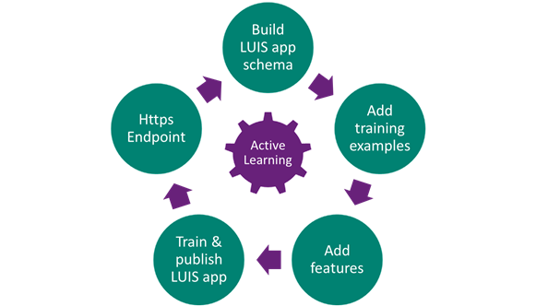

Figure 2.6: Microsoft Language Understanding (LUIS) Application Development Lifecycle

To successfully build a domain-specific language model, there are a few concepts and keywords in LUIS that need to be internalized:

* **Intents:** An intent represents actions the user wants to perform. The intent is a purpose or goal expressed in a user's input, such as calling for emergency help, finding the latest news feed, or paying the electricity bill. The intents are named and defined correspond to these actions.
* **Utterances:** An utterance is text input from the user that the application needs to understand. Sentences like "There is a fire right now", or a fragment of a sentence, like "heart attack" or "snakes." Utterances aren't always consistent as there can be many utterance variations for a particular intent.
* **Entities:** An entity represents detailed information that is relevant in the utterance. For example, in the utterance "Book a ticket to Paris", "Paris" is a location. By recognizing and labelling the entities that are mentioned in the user’s utterance, LUIS helps you choose the specific action to take to answer a user's request.

LUIS is so advanced in extracting entities that the developers can finally build applications that can understand sophisticated utterances with the help of top-notch machine learning algorithms as well as lexicon-based entities or a blend of both. After the model is trained and published, all output result can be extracted from an https endpoint in JavaScript Object Notation (JSON) format provided by the system.

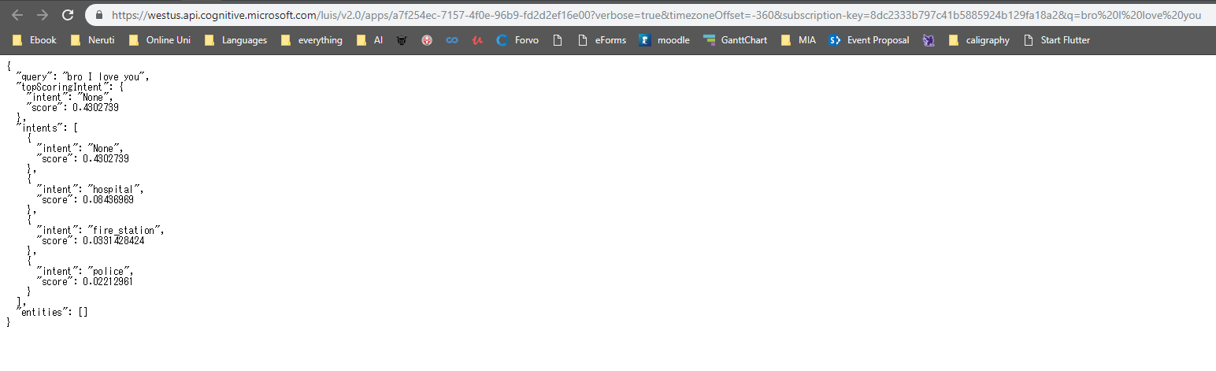

Figure 2.7: Example of https endpoint in JSON format (shown in a web browser)

Although this mobile application only works when the user has access to the internet and GPS feature on the mobile phone, there will be a button in the application that can dial directly to MERS. This feature is present for two purposes:

1. In the case of an emergency where there is no internet available, the user can make a MERS 999 call without exiting the application and go to the phone application.
2. When the user can’t describe the accident or incident precisely via the voice note feature, the user can also make a MERS 999 call so that a human operator can assist him or her better.

There will be some difficulties in expanding this mobile application to a global scale as different countries have different laws and regulations that are very specific to each organization. Regardless, the objective of this mobile application which is to provide the ability to call for an ambulance without going through the usual procedures and ensure the ambulance arrive at the required location using the shortest time possible can be realized by adapting and fine-tuning the application to the policies that are set by the Malaysia Ministry of Health.

### 2.1 similar applications that have been developed

Several similar mobile applications have been developed especially in countries like India where the response time for ambulances is critically high. In 2017, the chief minister of Chennai just launched a new GPS based mobile application that tracks the caller’s location via GPS and dispatches ambulance based on the location (Tripathi 2017). Nevertheless, the application doesn’t include any technology besides the implementation of GPS as the core of the service and it received mixed reviews from the public about the reliability of the service.

Another similar application that has been developed is an application called ‘The GoodSAM’ that instantly send a link to the 999 caller’s mobile phone which will open a live streaming video and gives the medics the ability to access the situation before setting off to save the victim. Other than that, GoodSAM application also incorporated a technology that can measure the patient’s pulse just from the live video stream. Beta phase feature such as measuring multiple patients’ pulse at once is already planned in the future [20].

One of the more successful ambulance applications is called “Stat” developed by a practicing pediatrician for the last 7 years, Dr Brian, in 2013. Stat application offered some features that are also present in this project application like the feature to extract user’s GPS location and send the appropriate ambulance help on the spot. The Stat application not only connects users with the nearby idle medical transportation vehicles but also with en-route medical crews through text, phone and video calls, to keep crews updated on developments. However, the application only works in both states, Philadelphia and Austin, and planned to be further expanded in the future [21].

Needless to say, emergency calling based mobile applications are still low in numbers compared to applications from other genres like health and fitness or education. In conclusion, the mobile application being developed for this project offers novelty and a new approach to tackle an age-old problem. The following sections will discuss more on the planning, software requirement specifications and implementation of the mobile application.

## 3.0 Scrum Framework

### 3.1 Product Backlog

* Database
* GPS integration
* Thumbprint verification login system
* User Interface (UI) design
* Google Map integration
* User account creation
* Multiple emergency departments integration
* Speech recognition technology integration
* Time estimation arrival for the emergency help
* Markers shown for nearest emergency centres

### 3.2 Release Backlog

* UI design
* User account creation
* Google Map integration
* GPS integration
* Database
* Speech recognition technology integration
* Markers shown for nearest emergency centres
* Multiple emergency departments integration

### 3.3 Sprints

|  |
| --- |
| **Sprint 1: (1st December 2018 – 31st January 2019)**   * creating account page * creating login page * creating startup page * linking pages together * create button to initiate call * implement GPS information extraction * implement voice recognition technology |
| **Sprint 2: (1st February 2019 – 31st February 2019)**   * creating database using Google Firebase * create and finalize UI design * test voice recognition keywords extraction’s accuracy * integrate multiple emergency departments |
| **Sprint 3: (1st March 2019 – 1st April 2019)**   * allow users to edit profile’s information * show markers of emergency centre on the map * polish and fix application’s bugs |

### 3.4 Burndown Chart

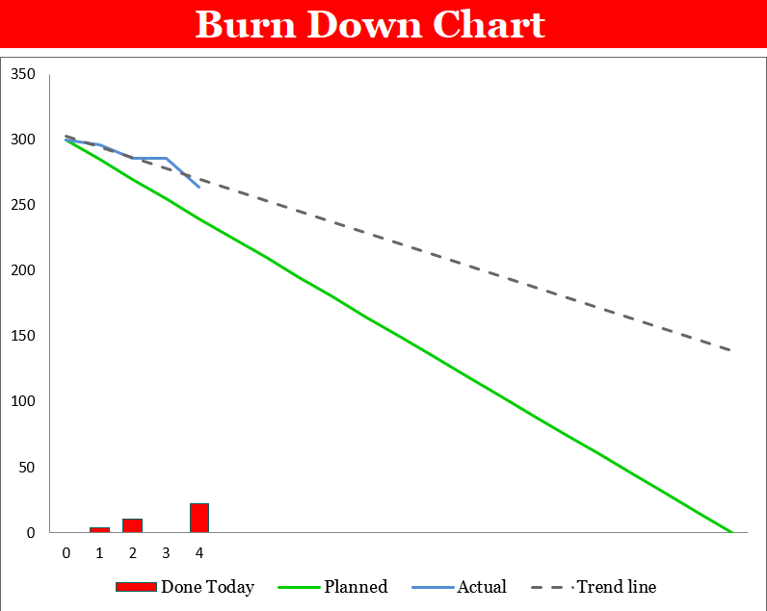

*Figure 3.4 Burndown Chart*

The burndown chart above corresponds to the Gantt chart for this project. The projected line is the optimum effort for the developer to put in each week. However, there will be setbacks and obstacles that will delay the process or occasions that will speed up the process. The blue line represents the actual time taken for the developer to create the designed application while the green line is the optimum time taken for the developer to complete the application.

## 4.0 Software Requirement Specification

### 4.1 Functional requirements

**1. Sign up an account**

The user can sign up for an account by entering their sign-up details (email address, password) on the sign-up page. After signing up, they are automatically logged in into the app.

**2. Login into app**

If the user is not signed in, the user can log in into the app by entering their login details (email address, password) on the login page.

**3. Sign out**

The user can sign out of the app and return to the main page of the app.

**4. View profile page**

The user can view personal detail on their profile page where their name, phone number is shown.

**5. Edit profile page**

The user can edit their details on their profile page if needed.

**6. Call for an emergency help / professional emergency operator**

The user can call for emergency help by tapping the emergency calling button on the main page. If the user wants to call a professional emergency operator, there is another button for that function.

**7. Profile authentication**

When the user signs up for the first time, the system will verify all details entered by the user. For example, if the user’s email already exists in the database, the system will return an error saying that the email exists in the database and the user will have to use another email to sign in or create a new account from scratch.

When the user tries to login into the app, the system will validate the email and the password of the user. If any of them does not match the database record, the system will return an error saying that either the email or the password is incorrect.

**8. Updating user database**

Whenever user data is changed in the app, the data will be sent to the database and it will be updated accordingly.

**9. Voice recognition keywords extraction**

When the user calls for an ambulance, there will be a pop up that allows the user to send in a voice note. The voice note will be analyzed by the voice recognition technology and convert it into text.

**10. Natural Language processing (NLP)**

Once the text is successfully extracted, it will be interpreted by NLP service in the cloud to determine the type of emergency the user is facing at the moment and deploy the fitting emergency help.

**11. GPS location extraction**

When the user calls for emergency help, the application will also extract the live location of the user via GPS in the smartphone in the format of latitude and longitude and send it to the right emergency service centre.

**12. Showing of emergency centre markers on the map**

Once location data and the type of emergency have been identified, there will be markers of emergency centres like police station, fire station or hospital appearing in the map view of the application for references.

### 4.2 Non-functional requirements

**1. Internet access is required at all time**

The application requires internet access at all time to be able to communicate with the database server when calling for emergency help.

**2. GPS of the mobile phone must be turned on**

When the user calls for an emergency, the application will need to access the location of the user via GPS in the smartphone and send it to the emergency service centre.

**3. An account must be created to use the application**

In order to utilize the functions of the application, the user will need to first create an account as the data and information being sent to the database is catered to the user individually.

### 4.3 UML Figures

#### 4.3.1 Use Case Figure

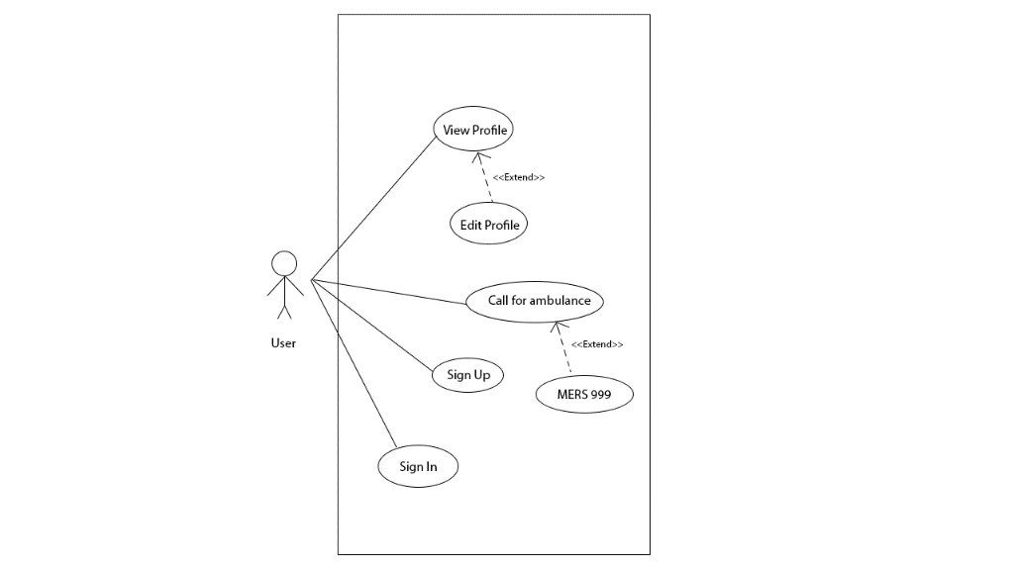

*Figure 4.3.1 Use case diagram*

|  |  |  |  |
| --- | --- | --- | --- |
| **No** | **Use Case** | **Relation** | **Description** |
| UC 1 | View Profile | Association  Extend UC 2 | Allows the users to view the details of their created profile (i.e. name, phone number) |
| UC 2 | Edit Profile | Association | Allows the users to edit their profile details if they want to |
| UC 3 | Call for ambulance | Association  Extend UC 4 | This is the main functionality of the application, allows users to call for emergency help by sending a voice note |
| UC 4 | MERS 999 | Association | Allows users to call MERS 999 directly if there are doubts or inquiries |
| UC 5 | Sign up | Association | Create a new account for this application |
| UC 6 | Sign in | Association | Login into the application by entering the account details |

#### 4.3.2 Activity Figure

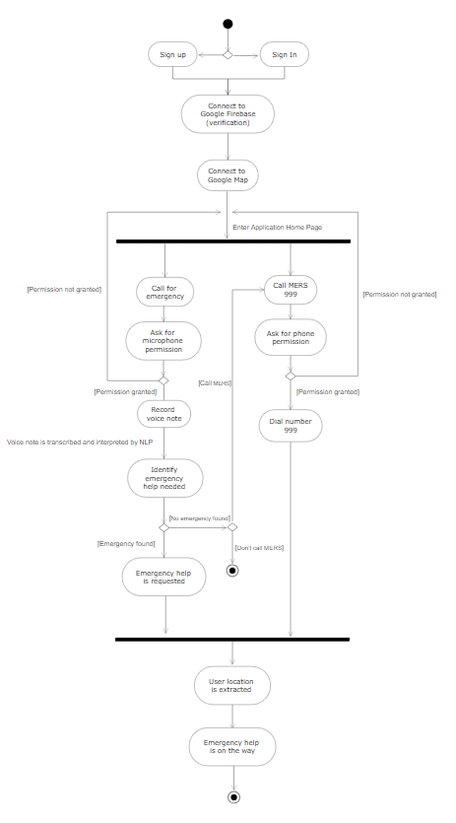

*Figure 4.3.2 Activity Figure (calling for emergency help)*

### 4.4 Prototypes

#### 4.4.1 Low-fidelity

Low-fidelity prototype is a rough sketch on a paper about the basic layout for our app. The following low-fidelity prototype serves as a backbone for our project.

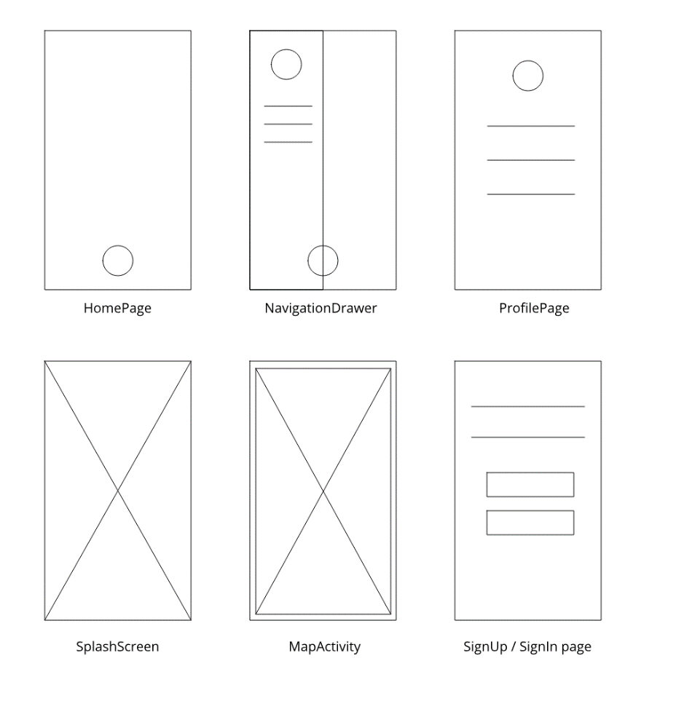

*Figure 4.4.1 Low-fidelity prototype*

#### 4.4.2 Mid-fidelity

A mid-fidelity prototype will contain a little bit more details compared to low-fidelity prototype. Images, icons and texts will be placed in the layout for better visual enhancement. The following mid-fidelity prototype shows the progress of our current app.

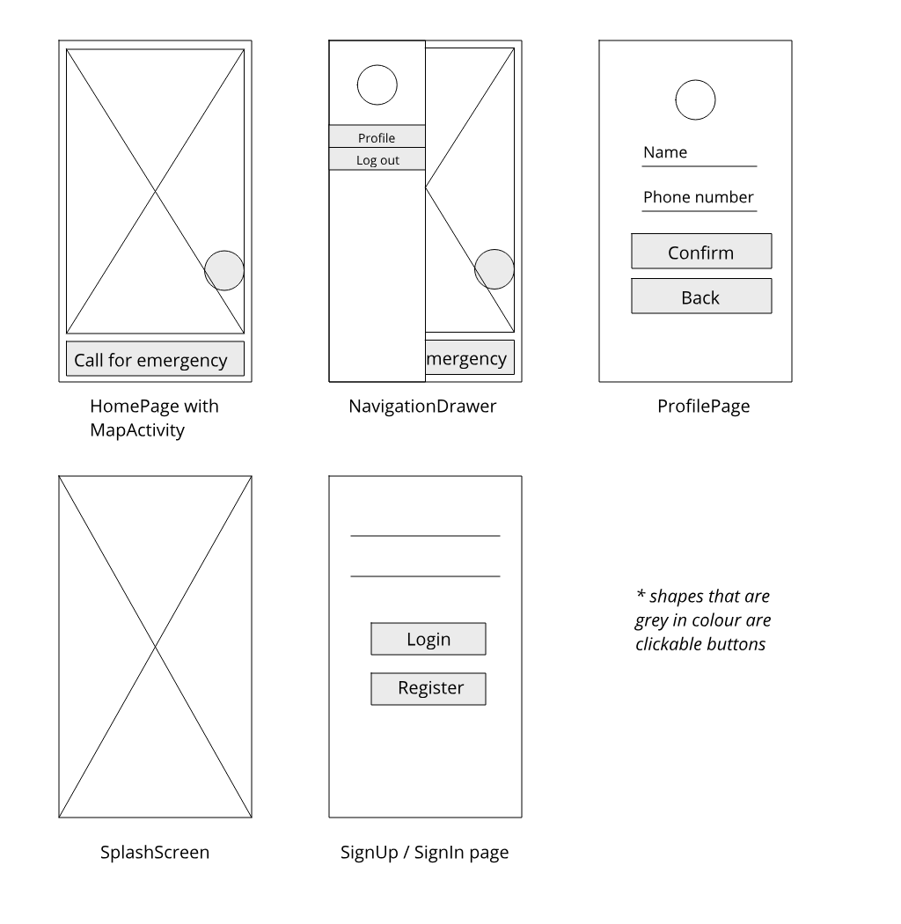

*Figure 4.4.2 Mid-fidelity prototype*

#### 4.4.3 High-fidelity

A high-fidelity prototype will look like a completed design of our project. Everything from UI design, images, texts, hover states etc have been added to the prototype. The following high-fidelity prototype will be our targeted design at the end of our project.

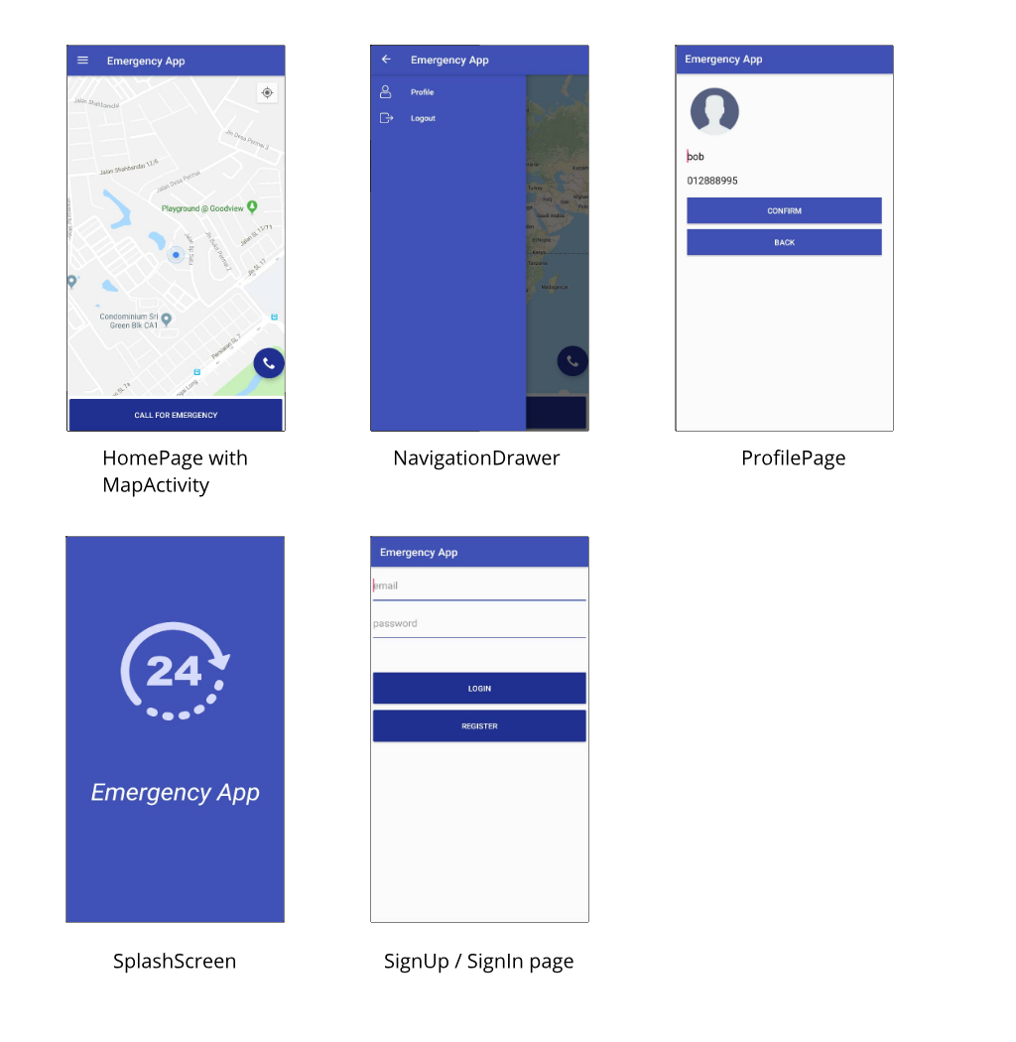

*Figure 4.4.3 High-fidelity prototype*

## 5.0 Implementation of project’s application

After a rigorous design process, the implementation of the application is planned and executed. When the implementation phase began, the project was split into 2 parts: frontend, which is the user interface of the application, and backend, which is the database side of the application. There are a lot of tools that are available in the market to turn this application into a reality but not all of them are compatible with each other. Hence, careful considerations have been made to ensure that both frontend and backend of the application work flawlessly and seamlessly together yet still give the user an anxiety-free user experience while using the application. Below are the tools that have been chosen and details on the pros and cons that the tools provide to the development process:

### 5.1 Tools used in the development process

#### 5.1.1 Android Platform

Every mobile development is developed with a targeted platform in mind. In our current society, the two omnipresent mobile platforms are Apple IOS and Google Android platform. Both platforms have their respective advantages and limitations. As for this project’s mobile application, the Android platform was chosen.

**Pros**

* + **Java and Kotlin as a programming language**

The programming language used to develop an Android application is Java which is nearly two decades old. Java is an object-oriented, cross-platform language that’s used everywhere from data analytics initiatives. Web, desktop, mobile, IoT products which mean there are tons of documentation available on the internet where most problems that are faced during development can be solved easily by referring to the documentation or blogs that had solved similar problems in the past.

* + **Simple app acceptance process**

Once an application is developed, it needs to be published to the platform’s app store in order to be downloaded by the public. During the publishing phase, Apple and Google have a different approval process. Apple is famous for its tedious and demanding approval process while Google is more laid back as long as the application doesn’t violate its content policies. Google approval process is loved by self-employed or indie developers as they don’t have to spend thousands of dollars in development only to be rejected by the company and failed to have the completed application published.

* + **The growing share of Android OS Usage in the Market**

For the last five years, Google Android operating system has captured a substantial amount of market shares in a different geographical and demographical range of users, which total up to two-thirds of mobile market shares worldwide. This has been made possible by having Google slowly spreading its Android operating system beyond the markets of USA, Canada, Australia and Europe. According to the current pace of growth, the total expected revenue made in the Google app store is projected to reach 189 billion dollars. By having the project’s mobile application developed in Android, the application can be reached and used by more users despite the limited amount of time and money were given for the development of this application.

* + **It’s cheaper and quicker to develop Android application**

Android’s open working model and flexible ways to commit to development factors along with the easy availability of resources make it cheap and quick to develop an application on Android. The required tools needed to develop an Android application like Android Studio is available in all major computer platforms like Windows, Macs and Linux. As for Apple application’s development, it requires the user to purchase a Mac computer, which is pricey in comparisons with Windows-based computers, only then the developer will be granted access to its proprietary development software which is known as XCode.

**Cons**

* + - **Device fragmentation**

Given the omnipresence of Android devices, there is no doubt that device fragmentation is a serious issue faced by Android developers. Different mobile devices’ manufacturers release devices that have their own screen size, sensors, performance issues, and graphics drivers. To create a perfect Android application, a lot of testing needs to be done on the application to guarantee the application can adapt itself to multiple types of devices, which increase development time in the long run.

* + - **Security issues**

Android operating system is open-source to the developers where they can redistribute and modify the original Android code freely. However, this development freedom also comes with a price as there are malware and hacks that target millions of Android users weekly. Although Google has tried its best to release security patches, the application developers are always finding ways to protect the users’ data by integrating more complex encryption, including additional layers of security features or avoiding the input of personal data altogether.

#### 5.1.2 Adobe Illustrator

“If you think good design is expensive, you should look at the cost of bad design” a quote by the CEO of Jaguar Land Rover beautifully summarizes the importance of good design in everything especially mobile application’s user interface. Besides experimenting with the user interface design in paper prototypes format, specific vector drawing tool is also needed to draw and create vector images, icons, logo etc. that will be used in the application. After testing different tools, Adobe illustrator was chosen.

**Pros**

* + **Improved precision in creating vector arts**

Adobe Illustrator is loved by many graphic designers for many reasons. In creating arts, the smallest mistake in details can turn a masterpiece into a failure. By having tools that are very precise, graphic designers can create arts that are full of fine details. The user can design projects of any size or scope from start to finish and always given sharp, crisp lines that are print-ready in any dimension. There will be no loss of resolution too when graphics are created through this program, which means there is more versatility when designing multimedia for various purposes.

**Cons**

* + **It has a very steep learning curve.**

**Unlike other graphic design programs, Adobe Illustrator has a steeper learning curve as it gives the user so many options and ways to design a single artwork. It requires an enormous amount of patience on the designer’s part to create high-quality work.**

* + **It does not handle pixel art**

**Adobe Illustrator doesn’t allow the user to draw pixels which might be a problem to the designer that want to create some art in pixelated format.**

#### 5.1.3 Google Firebase

Every application that involves any type of input or processing of data requires a backend database to handle the workload. Since the mobile application being developed is based on Google’s Android platform, the first ideal database choice would be Google own Firebase database.

**Pros**

* + **Firebase setup and free tier plan**

**For a traditional backend approach, it takes a lot of time and effort to create and set up a database server from authentication, email, versioning, hosting, monitoring, devops and uptime. By having the database server maintained by Google, the user can set up the whole backend in less than five minutes with the least amount of cost as Google provides the user with a generous free tier plan that is sufficient for most indie developers.**

* + **Extensive documentation**

**Besides having an easy-to-learn database API, the documentation provided for beginners of Firebase is in its league of its own. Everything from storing and reading user data is explained in a concise manner with detailed code examples.**

**Cons**

* + **Firebase backend is proprietary**

**Although setting up Firebase is painless, but the Firebase server is completely proprietary. This indicates that if Google shut down Firebase in the future, the developers must rewrite everything from scratch and can’t move the data from the server to another server. Firebase is also unique in the way it interacts with the APIs and Real-time components, making a frontend migration a massive ordeal too.**

#### 5.1.4 Google Android Speech-to-Text API

The mobile application that is being developed needs to be able to convert the users’ voice note into text format to be interpreted so appropriate emergency can be deployed based on the voice note. There are many speech-to-text services available in the market most notably Google Speech, IBM Watson and DialogFlow. After comparing all these services, Google Android Speech-to-Text API best suit the function that the mobile application needs.

**Pros**

* + **It is free**

**Unlike many speech-to-text API that is provided in the market that requires developers to subscribe to an annual subscription fee, Google Android Speech-to-text API is totally free which cut down the mobile application development cost tremendously.**

**Cons**

* + **It only works with Android phones**

**Google Android Speech-to-text API uses Android platform built-in system and microphone to record users’ voice and convert them into text and stored them in an array of strings in real time. The array of strings can then be passed into a language understanding API that determines the words that were being said and execute the appropriate functions based on the situation.**

#### 5.1.5 Google Maps / Places API

Once the audio file was interpreted, the location data is required to be sent to the appropriate emergency service centres. Google Maps / Places API was chosen for its accuracy and reliability compared to other Maps API like Foursquare’s Places API.

**Pros**

* + **Maps accuracy**

**Google's database is largely from licensed providers whose business model is to provide "authoritative" information. These sources are often out-of-date, but what data they do have is generally reliable. Besides that, Google has 50MM places in its database which ensure that their coverage in all major markets is strong.**

* + **Categories filtering**

**Google's categories are a mapping of category data received from various listing providers into a single list of categories. These categories can be considered "verified," in that they generally stem from a "trustworthy" classification source as compared to Foursquare’s Places API that is largely based on the community of the users.**

#### 5.1.6 Microsoft Language Understanding API (LUIS)

Once the audio file was converted into an array of strings, they will be passed to a NLP service to be interpreted on the spot and predict what emergency was the user-facing at that moment. Since natural-language-processing technology has advanced significantly in recent years, the amount of natural-language-processing API available in the market is quite saturated. In the end, Microsoft Language Understanding API is used in the development of this mobile application.

**Pros**

* + **Machine Learning in the cloud**

Microsoft Language Understanding is a cloud-based API service that applies custom machine-learning intelligence to a user's conversational, natural language text to predict overall meaning, and pull out relevant, detailed information [22]. By having machine learning service in the cloud, developers can experiment with different machine learning capabilities and scale up the project without having to have advanced skills in artificial intelligence and data science [23]. Thus, more time can be allocated for the designs and functionalities of mobile applications.

* + **Cost is lower**

**Although there are various open source machine learning frameworks, such as TensorFlow, MXNet etc. that can run locally on the developers’ hardware, but it is not as efficient as machine learning in the cloud. Training real-world models requires large compute clusters which entail computational and special-purpose hardware requirements that will contribute to a higher cost for development and infrastructure. Therefore, having a machine learning infrastructure that is provided by Microsoft, most hardware investment cost can be used in other aspects of the mobile application.**

* + **Easy Implementation in Android application**

**The simplicity of Microsoft Language Understanding API enables developers to implement natural-language-processing capabilities into an Android application while still maintaining the ease of use factor of the application for the users.**

### 5.2 Design and architecture of the application

#### 5.2.1 Frontend

**After the right tools have been selected for the creation of this mobile application, a simple overview of the architecture design is needed to make sure the application is created based on the blueprint to avoid any confusions and uncertainties during the development process.**

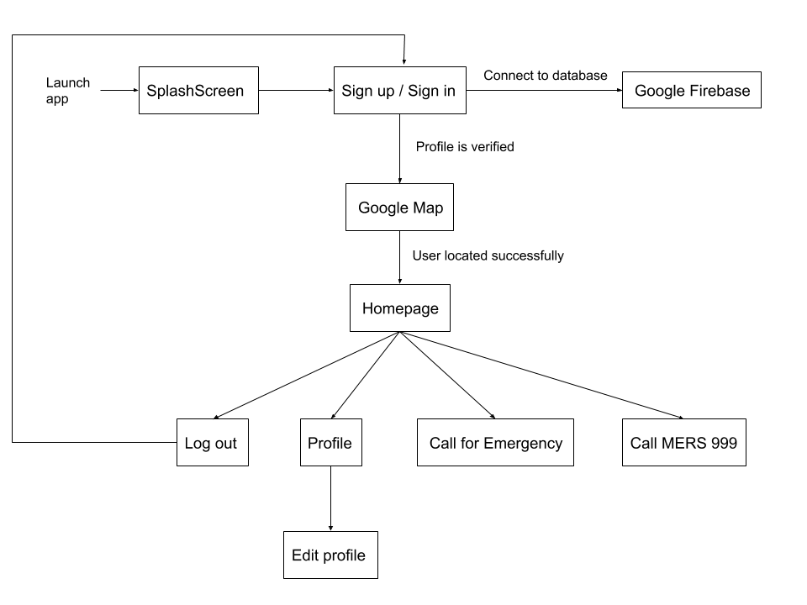

*Figure 5.2.1 Simple Frontend Architecture Design*

**As seen in Figure 5.2.1, the architecture design of the application is easy to understand and logical to be implemented. The first part of the application is the connection between the frontend and the backend. Once the application is launched, it will directly connect to the database (Google Firebase) if there’s Wi-Fi or mobile data. After the connection is established, the user is brought to the user profile creation phase. If the user has registered himself or herself as a user and logged in into the application, the user is presented with several buttons that trigger different functions.**

**The main function of this application is the “call for emergency” button which records a voice note of the user upon button clicked, and instantly convert the voice note into the text to be analyzed by the natural-language-processing API which is Microsoft Language Understanding (LUIS) in real time. Once the text was analyzed, the result of the analysis will be sent back to the application and determine which type of emergency will be deployed such as hospital, police or fire stations. While the natural-language-processing API is processing the text, the application will also extract the precise current position of the user in the format of latitude and longitude and send it to the database. The processes discussed above will be running in parallel using different threads in the Android mobile system. If both location data and emergency needed are obtained, the map will be filled with markers of the nearest emergency places (police station, fire station, hospital) so the user can have a rough estimation on how long it takes for the emergency help to arrive. Clicking on a specific marker will also reveal the name and the address of the place.**

**The “call for emergency” function requires the user to be connected to the internet. In the midst of an emergency, there might be possibilities where the WI-FI or mobile data connection is not stable, interfering the function of the app not executing as it should. Therefore, there is another button which has an icon of a phone that can call MERS 999 directly without the need to leave the application to use the default phone call application. Besides that, there is also a possibility where the user is not confident enough to describe the situation that he or she is facing via the pop-up voice note. By having the “call MERS 999” button, the user can rest assured that during an emergency this application can serve his or her purpose reliably.**

**Other than that, the user can click on the hamburger menu which is located on the top left of the application to reveal a side navigation drawer. Inside the navigation drawer, there are two buttons which are “Setting” and “Log out”. By clicking on the setting button, the user will be brought to a setting page which contains the details of the user (name, phone number) that can also be edited directly on that page and updated through Google Firebase. By clicking on the logout button, the user will be log out from the application and be brought back to the signup/sign in page.**

#### 5.2.2 Backend

Architecture design is also applied to the backend of an application. It shows how the data and information gathered from the application are stored in the database in an organized and systematic way.

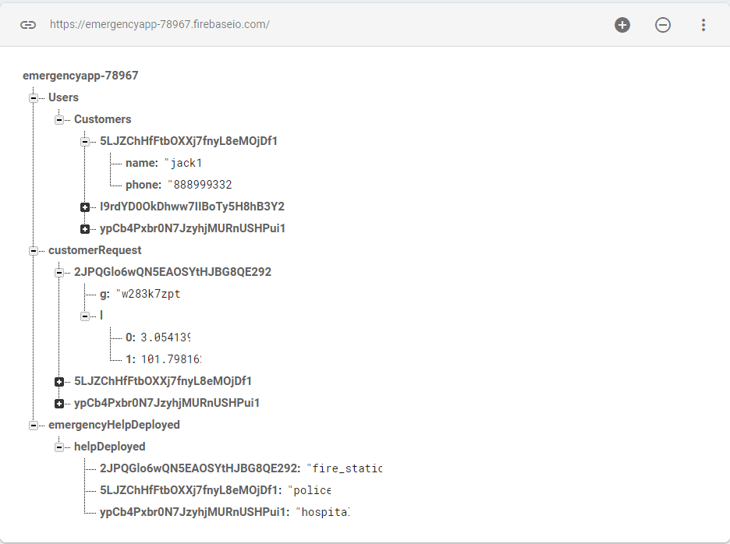

*Figure 5.2.2 Backend Architecture Design*

Based on Figure 5.2.2, the database design is kept being as minimal as possible. There are three categories to the database which are “Users”, “Customer Request” and “Emergency Help Deployed”. Under the Users category, there is a subcategory which is “Customers” that contains the details like name and phone number of the user that has signed up for an account to use this application.

As for the “Customer Request” category, it contains the latitude and longitude the user that has called for help using the application’s “call for emergency” button. For the “Emergency Help Deployed” category, there is a sub-category called “Help Deployed” that records the type emergency that has been deployed (police station, hospital, fire station) to the user that called for help. All data are kept in the database permanently and can be referred at any given time by the admin of the database.

## 6.0 Results & Discussions

For every project that is being developed, it is necessary to test the reliability and dependability of software, as it will be used by the public in the future. At the same time, the test result can be used to justify the reason for implementing this software into the MERS 999 system that is currently operating. In this section, a test will be run on the software to show the accuracy of the voice recognition and NLP system. The test will be carried out as followed in orders:

1. Multiple sentences will be input into the software and check whether the speech was transcribed correctly **[Voice recognition test]**
2. Check and verify whether the output of the software satisfies the request made in the sentences **[NLP test]**
3. Show the score differences of the output because a sentence will generate 4 outputs, the output with the highest ‘intent’ score will be chosen as the final output

### 6.1 Voice recognition test

The following table is the result of the 1st test (spoken sentences contain accent and slang from local Malaysians in text form):

|  |  |
| --- | --- |
| **Spoken sentences** | **Transcribed sentences in text form** |
| 1. Help! There’s a fire in the house | "help there's a fire in the house" |
| 1. Burglar is inside my house right now, help me! | "burglars inside my house right now help me" |
| 1. I think I saw a snake in my house now, can someone come and catch it? | "I think I saw a snake in my house now can someone help me catch it" |
| 1. Help, heart attack arrhhhhhh | "help heart attack" |
| 1. Hahahahahaha, this app is a joke, blahhhh | “this app is a joke blah" |
| 1. (made coughing sound) serious cough, I can’t breathe | "serious cough I can't breathe" |
| 1. Help … I am dying now, help | "help I'm dying now" |
| 1. Someone is very noisy here, need help stopping them | "someone is very noisy who needs help stopping them" |
| 1. Man, who wants to use this app | “man who want to use this app” |
| 1. I think there’s a burglar in my house right now lor, I need someone to catch them lor | "I think there is a burglar in my house right now lol I need someone to catch them law" |
| 1. I’m dying now ah, no one want to help me meh | "I'm dying now are the 112 company man" |
| 1. Ei, someone has a heart attack lah, need help fast | "someone has a heart attack need help class" |
| 1. This app can or not bo, like no use want | "this app cannot borderline I use one" |
| 1. Police, we need your help now leh, weih, weih, police can you hear me ah | "please we need your help now they're way way police can you tell me how" |
| 1. I need help solving my heartbreak lah | "I need help solving my Heartbreak Lola" |
| 1. I cannot forget about her leh, my heart is broken | "I cannot forget her Lee my heart is broken" |
| 1. There is a car accident right now, 2 persons are injured badly, need an ambulance | "there's a car accident right now two persons are injured badly need an ambulance" |
| 1. No hope for humanity | "no hope for humanity" |
| 1. I want to eat some mcdonalds | "I want to eat some McDonald's" |
| 1. Any money that I can borrow here? | "any money that I can borrow here" |

*Table 6.1 spoken sentences to transcribed text*

As seen in table 6.1, the voice recognition software was not able to transcribe weird accent and slangs that are only common among Malaysians or Singaporeans. On a brighter note, important keywords were still picked up successfully and the slangs transcription problem can be solved by having more voice training data from Malaysians for the machine learning models.

### 6.2 NLP test

The following table is the result of the 2nd test (transcribed sentences and the final output):

|  |  |
| --- | --- |
| **Transcribed sentences in text form** | **Output (intent)** |
| 1. "help there's a fire in the house" | "fire_station" |
| 1. "burglars inside my house right now help me" | "police" |
| 1. "I think I saw a snake in my house now can someone help me catch it" | "fire_station" |
| 1. "I think there is a burglar in my house right now lol I need someone to catch them law" | "police" |
| 1. "help heart attack" | "hospital" |
| 1. “this app is a joke blah" | "None" |
| 1. "serious cough I can't breathe" | "hospital" |
| 1. "help I'm dying now" | "hospital" |
| 1. "someone is very noisy who needs help stopping them" | "hospital" |
| 1. “man who want to use this app” | "None" |
| 1. "I'm dying now are the 112 company man" | "hospital" |
| 1. "someone has a heart attack need help class" | "hospital" |
| 1. "this app cannot borderline I use one" | "None", |
| 1. "please we need your help now they're way way police can you tell me how" | "police" |
| 1. "I need help solving my Heartbreak Lola" | "None" |
| 1. "I cannot forget her Lee my heart is broken" | "None" |
| 1. "there's a car accident right now two persons are injured badly need an ambulance" | "hospital" |
| 1. "no hope for humanity" | "None" |
| 1. "I want to eat some McDonald's" | "None" |
| 1. "any money that I can borrow here" | "None" |

*Table 6.2 transcribed sentences and the final output*

As seen in table 6.2, only sentence number nine request is not met properly as the output should be “police” instead of “hospital”. Similarly, this problem can be solved by having more training data like call logs from the emergency centres to increase the machine learning model’s capability in handling unusual requests.

### 6.3 Comparison of intents score

The following table is the result of the 3rd test (seeing the score differences between different intents)

|  |  |
| --- | --- |
| **Transcribed sentence** | **Intents score comparison** |
| 1. "help there's a fire in the house" | "intent": "fire_station",  "score": 0.9310286  "intent": "police",  "score": 0.0576592833  "intent": "hospital",  "score": 0.03301866  "intent": "None",  "score": 0.00170590892 |
| 1. "burglars inside my house right now help me" | "intent": "police",  "score": 0.398529261  "intent": "hospital",  "score": 0.124263205  "intent": "fire_station",  "score": 0.09678754  "intent": "None",  "score": 0.01173824 |
| 1. "I think I saw a snake in my house now can someone help me catch it" | "intent": "fire_station",  "score": 0.4983179  "intent": "police",  "score": 0.178702191  "intent": "hospital",  "score": 0.04005976  "intent": "None",  "score": 0.0261618048 |
| 1. "I think there is a burglar in my house right now lol I need someone to catch them law" | "intent": "police",  "score": 0.88539207  "intent": "hospital",  "score": 0.04739633  "intent": "None",  "score": 0.0425876342  "intent": "fire_station",  "score": 0.03116488 |
| 1. "help heart attack" | "intent": "hospital",  "score": 0.9245164  "intent": "None",  "score": 0.0429200679  "intent": "fire_station",  "score": 0.0203791577  "intent": "police",  "score": 0.005094251 |
| 1. “this app is a joke blah" | "intent": "None",  "score": 0.84565115  "intent": "hospital",  "score": 0.0347205661  "intent": "fire_station",  "score": 0.0192585625  "intent": "police",  "score": 0.0151194623 |
| 1. "serious cough I can't breathe" | "intent": "hospital",  "score": 0.6800363  "intent": "None",  "score": 0.21186541  "intent": "police",  "score": 0.0237678513  "intent": "fire_station",  "score": 0.0124389883 |
| 1. "help I'm dying now" | "intent": "hospital",  "score": 0.905033  "intent": "None"  "score": 0.035998024  "intent": "fire_station"  "score": 0.02430912  "intent": "police",  "score": 0.0107214274 |
| 1. "someone is very noisy who needs help stopping them" | intent": "hospital",  "score": 0.5510082  "intent": "police",  "score": 0.07351669  "intent": "None",  "score": 0.04403167  "intent": "fire_station",  "score": 0.0325366743 |
| 1. “man who want to use this app” | "intent": "None",  "score": 0.955491662  "intent": "police",  "score": 0.0375696756  "intent": "hospital",  "score": 0.0128970137  "intent": "fire_station",  "score": 0.0110822255 |
| 1. "I'm dying now are the 112 company man" | "intent": "hospital",  "score": 0.162557364  "intent": "police",  "score": 0.135617539  "intent": "None",  "score": 0.1106086  "intent": "fire_station",  "score": 0.0337052755 |
| 1. "someone has a heart attack need help class" | "intent": "hospital",  "score": 0.8882348  "intent": "police",  "score": 0.0471218079  "intent": "None",  "score": 0.0300489478  "intent": "fire_station",  "score": 0.0118297907 |
| 1. "this app cannot borderline I use one" | "intent": "None",  "score": 0.799618244  "intent": "hospital",  "score": 0.03693906  "intent": "police",  "score": 0.024236029  "intent": "fire_station",  "score": 0.0171836 |
| 1. "please we need your help now they're way way police can you tell me how" | "intent": "police",  "score": 0.9081048  "intent": "hospital",  "score": 0.193476737  "intent": "None",  "score": 0.0113353319  "intent": "fire_station",  "score": 0.005895607 |
| 1. "I need help solving my Heartbreak Lola" | "intent": "None",  "score": 0.868019938  "intent": "hospital",  "score": 0.0528984442  "intent": "police",  "score": 0.0171895735  "intent": "fire_station",  "score": 0.01513793 |
| 1. "I cannot forget her Lee my heart is broken" | "intent": "None",  "score": 0.9248262  "intent": "police",  "score": 0.02801773  "intent": "hospital",  "score": 0.01912085  "intent": "fire_station",  "score": 0.01314242 |
| 1. "there's a car accident right now two persons are injured badly need an ambulance" | "intent": "hospital",  "score": 0.9214137  "intent": "police",  "score": 0.07357824  "intent": "None",  "score": 0.0178492628  "intent": "fire_station",  "score": 0.007355585 |
| 1. "no hope for humanity" | "intent": "None",  "score": 0.7351068  "intent": "hospital",  "score": 0.03716699  "intent": "fire_station",  "score": 0.0267145634  "intent": "police",  "score": 0.0139409676 |
| 1. "I want to eat some McDonald's" | "intent": "None",  "score": 0.522152  "intent": "hospital",  "score": 0.09804569  "intent": "police",  "score": 0.0413041078  "intent": "fire_station",  "score": 0.0163398385 |
| 1. "any money that I can borrow here" | "intent": "None",  "score": 0.251582235  "intent": "hospital",  "score": 0.16649799  "intent": "police",  "score": 0.0491494164  "intent": "fire_station",  "score": 0.02173813 |

*Table 6.3 score comparisons between different intents*

## 7.0 Contribution and reflections

Throughout the journey of researching about MERS and EMS, I was truly inspired and grateful for what the government has built in the past to improve the quality of life of citizens. There is an old phrase, “If it ain't broke, don't fix it”. The current MERS that we have is not broken at all, but it is definitely lacking in some areas. In the age of technology, everything is moving swiftly and rapidly. If we don’t start finding solutions or ways to improve our system, it will be the cause of slow accelerating change. This is the sole reason why this project was proposed, and I have no regrets in choosing the path of developing a mobile application. Through this mobile application, I can see what does the future entails for MERS and I hope everyone that is involved with MERS in the future can build on top of what have been done in this project. As the saying goes, “it is not a faith in technology, it is faith in people”, technology doesn’t change the world, it is the people that created the technology change the world.

## 8.0 Bibliography

[1] F. Jiang *et al.*, “Artificial intelligence in healthcare: past, present and future,” *Stroke Vasc. Neurol.*, vol. 2, no. 4, pp. 230–243, 2017.

[2] H. Gary, “Why 999 for an emergency?,” 2010. [Online]. Available: http://news.bbc.co.uk/local/london/hi/people_and_places/history/newsid_8675000/8675199.stm. [Accessed: 04-Apr-2019].

[3] V. Surentheran, “Health Ministry under fire over deadly ambulance cases,” Kuala Lumpur, p. 1, Oct-2016.

[4] “General Road Accident Data in Malaysia (1997 – 2016).” [Online]. Available: https://www.miros.gov.my/1/page.php?id=17. [Accessed: 12-Dec-2018].

[5] eNotes, “‘How fast can someone bleed to death?,’” 2010. [Online]. Available: https://www.enotes.com/homework-help/how-fast-can-someone-bleed-death-178685. [Accessed: 12-Dec-2018].

[6] N. Rahman, C. H. Shah, and C. Holliman, *Prehospital Emergency Medical Services in Malaysia*, vol. 32. 2007.

[7] “999 is 80 years old today,” 2017. .

[8] L. R. Anas, “GIS in emergency communication - The MERS 999 experience,” 2012. [Online]. Available: http://ngis.mygeoportal.gov.my/. [Accessed: 12-Dec-2018].

[9] C. Chin, “Public has wrong perception of emergency number,” p. 1, 15-Mar-2015.

[10] “What is EMS?” [Online]. Available: https://www.ems.gov/whatisems.html. [Accessed: 19-Nov-2018].

[11] H. Pieterse and M. S. Olivier, “Android botnets on the rise: Trends and characteristics,” in *2012 Information Security for South Africa*, 2012, pp. 1–5.

[12] C. Rizos, “Introducing the Global Positioning System, chap. 7, Manual of Geospatial Science and Technology, J. Bossler, J. Jenson, R. McMaster & C. Rizos.” Taylor & Francis Inc, 2002.

[13] M. G. Wing, A. Eklund, and L. D. Kellogg, “Consumer-Grade Global Positioning System (GPS) Accuracy and Reliability,” *J. For.*, vol. 103, no. 4, pp. 169–173, 2005.

[14] “How GPS works.” [Online]. Available: https://www.gps.gov/multimedia/poster/poster.txt. [Accessed: 19-Nov-2018].

[15] E. Corbett and A. Weber, “What Can I Say?: Addressing User Experience Challenges of a Mobile Voice User Interface for Accessibility,” in *Proceedings of the 18th International Conference on Human-Computer Interaction with Mobile Devices and Services*, 2016, pp. 72–82.

[16] P. Das, K. Acharjee, P. Das, and V. Prasad, *VOICE RECOGNITION SYSTEM: SPEECH-TO-TEXT*, vol. 1. 2015.

[17] K. A. Kemble, “An introduction to speech recognition,” *Voice Syst. Middlew. Educ. Corp.*, 2001.

[18] R. Seth, “Machine Learning for Natural Language,” 2019. .

[19] S. Joseph, “LUIS.AI: Automated Machine Learning for Custom Language Understanding,” 2018. .

[20] H. Crounch, “‘Game-changing’ app allows air ambulance services to view patients,” *Digital Health*. [Online]. Available: https://www.digitalhealth.net/2018/05/game-changing-app-ambulance/. [Accessed: 22-Mar-2019].

[21] B. Hargrave, “Stat app is like Uber, but it sends an ambulance,” *USA Today*. [Online]. Available: https://www.usatoday.com/story/tech/2013/09/14/stat-app-medical/2631837/. [Accessed: 22-Mar-2019].

[22] Diberry, “What is Language Understanding (LUIS) - Azure Cognitive Services,” 2019. [Online]. Available: https://docs.microsoft.com/en-us/azure/cognitive-services/luis/what-is-luis. [Accessed: 04-Apr-2019].

[23] H. Guy, “What are the Benefits of Machine Learning in the Cloud?,” 2019. [Online]. Available: https://cloudacademy.com/blog/what-are-the-benefits-of-machine-learning-in-the-cloud/. [Accessed: 05-Apr-2019].